Drax: Guide/Set Control Notes

- Big Picture
The DEC & RA Guide/Set motors are controlled by relays in RA relay box which is mounted in the West side of RA housing. (the long flat box nearest the West access panel). The relays are activated by 9 x 24v DC signals shown on the ‘RA interconnection’ circuit. The switch/pushbuttons on this drawing are simplified and are shown for clarity/function only. The 10 conductors are:
2 wires, 24v & 0v supply. The 0v is only needed for the wired handset LED and Wi-Fi electronics.
4 wires, DEC Up & Down, RA Up & Down. Self-explanatory.
1 wire, Brakes off. Via relays RL4 & 10 this applies power to all the motor brake release solenoids and also to the motor control relays, ensuring that the motors cannot be operated when the brakes are on. (the brakes are currently adjusted off and the solenoids disconnected).
1 wire, Guide/Set. Via relays RL9 and 15 this enables reversing relays RL6 & 8 and RL12 & 14 to activate when a motor is operated. (this was perhaps not the smartest approach and may have to change)
2 wires, RA Enable + Return. This disables the sidereal drive (and therefore RA Guide/set motors) avoiding multiple inverter power cycling during setup/maintenance.

In practice, the above control signals are provided by the Guide/Set Control unit which allows control via a wired handset or a Wi-Fi remote handset.

- Guide/Set control unit

Referring to Drg XX (Drax: Guide/Set motor control)
The combination SW1 and the relay module RM1 switch motor control between the wired or Wi-Fi handsets.

Wired operation is similar to the simplified switching shown on Drg xx (RA interconnection) except with the complication of routing the RA-enable signal through default RM1 contacts.

When wired operation is selected both the Wi-Fi receiver U1, and RM1, are powered off and the default RM1 contacts allow operation of the wired handset. This guarantees that any failure of solid-state components (U1 & RM1) will not prevent operation of the wired handset. To further protect against failure due to voltage transients in the electrically noisy environment, the only conductors common to Drax and U1/RM1 inputs are 0V and 24v. With hindsight, a separate unregulated/reliable supply may have been preferable.

When Wi-Fi operation is selected U1 receives and decodes control codes from the Wi-Fi handset and outputs appropriate RM1 control signals from GPIO16-19 and 21-23. RM1 inputs are optically isolated but this is redundant given the coil-contact isolation.

The Guide/Set motor control unit is mounted externally on the RA housing door to enable the Wi-Fi signal. An approx. 6m cable connects the wired handset.

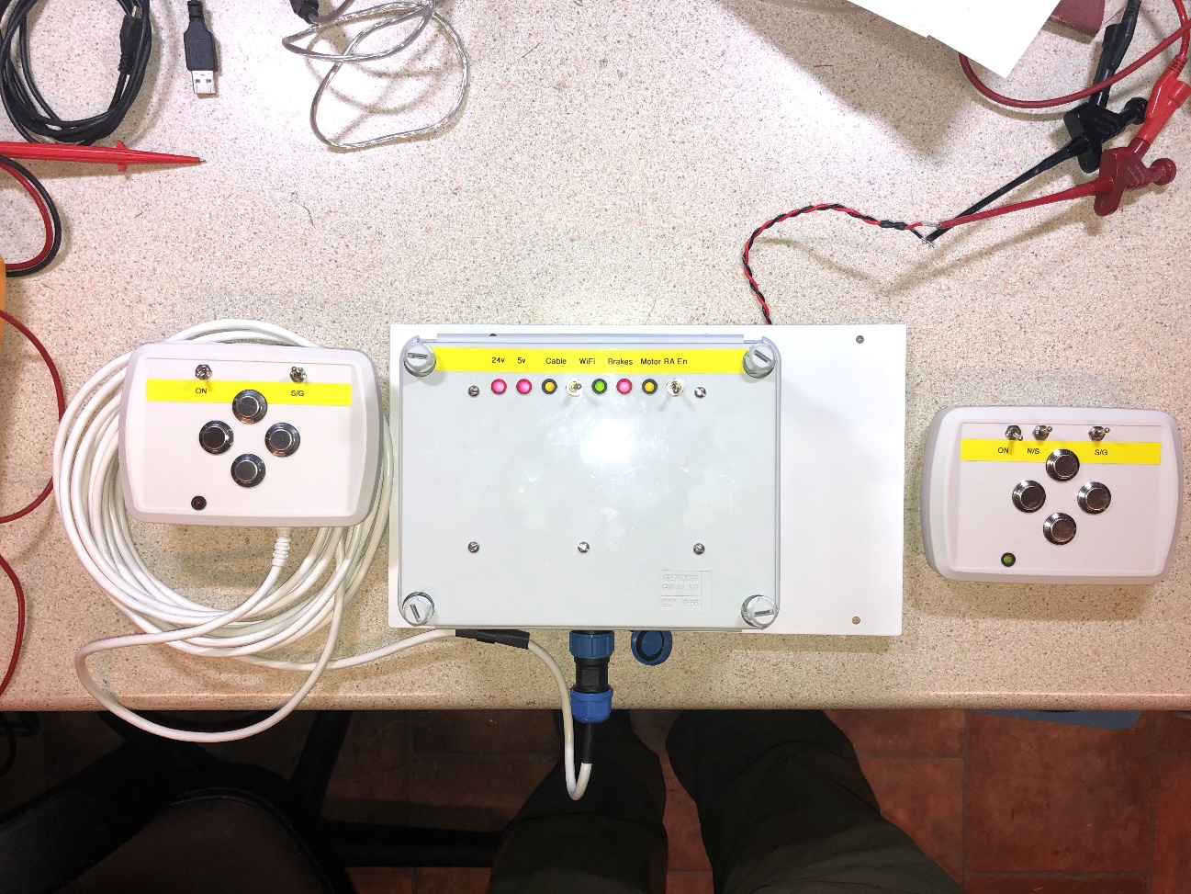

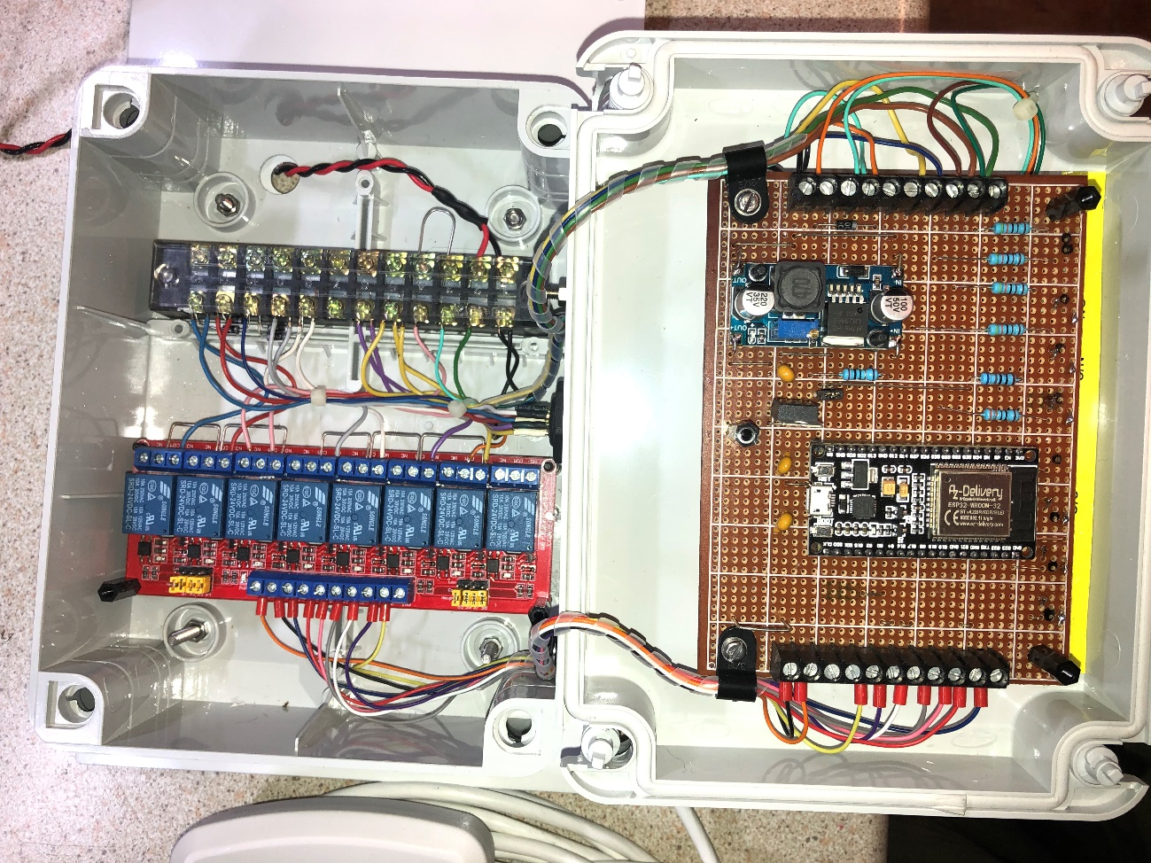
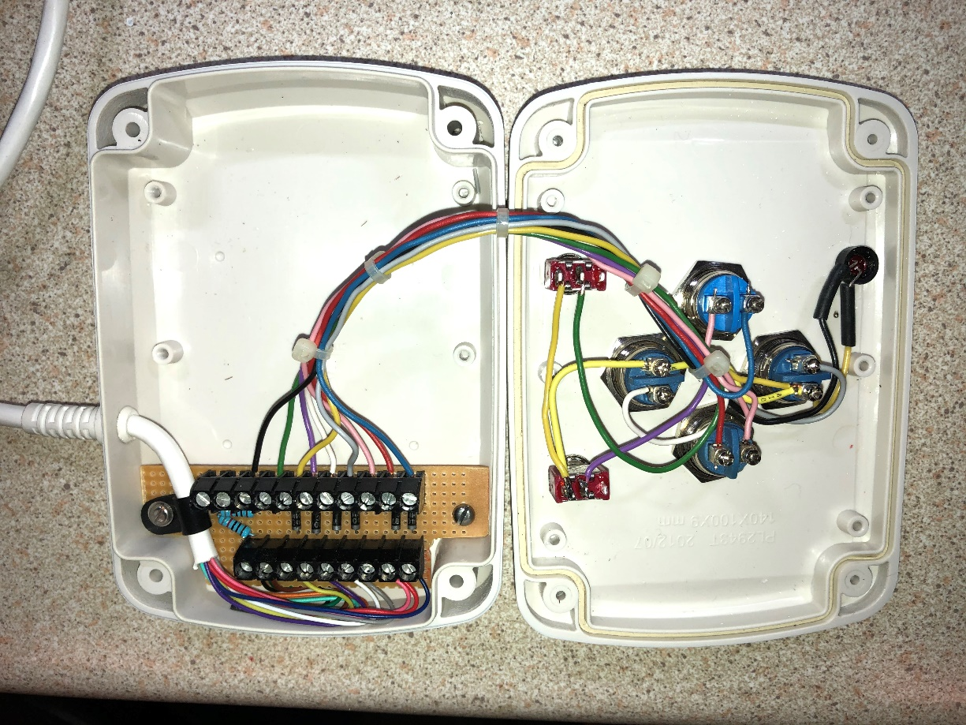

- Guide/Set Wi-Fi Handset

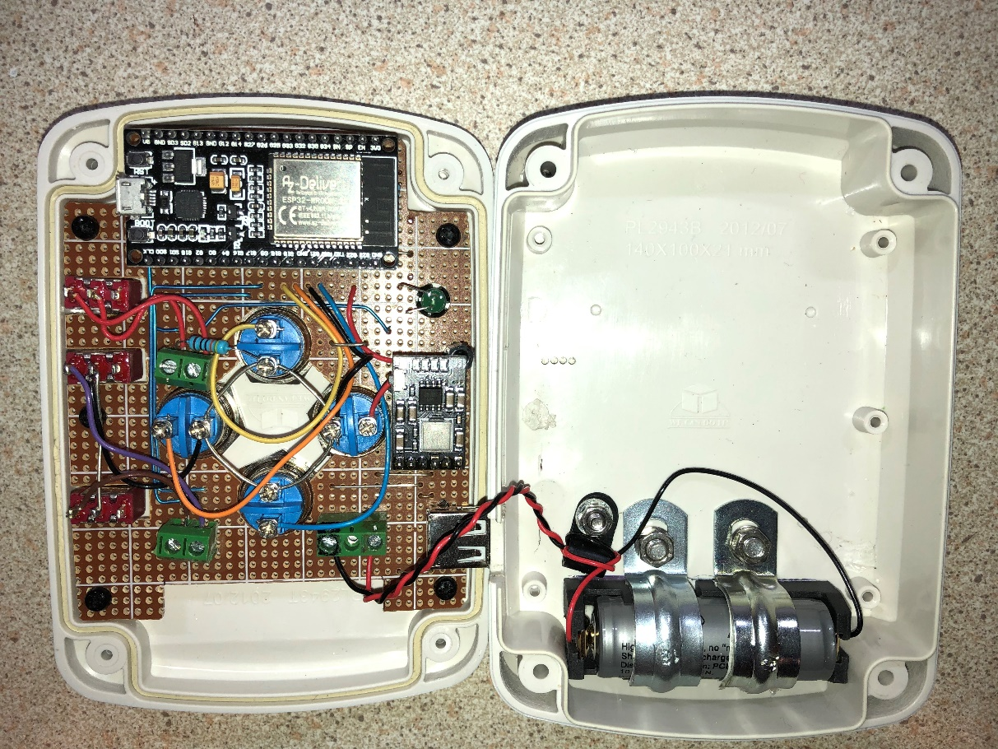

- Software (Wi-Fi remote)

Wi-Fi remote control is via a commercial router using UDP protocol. A router is used such that the guide/set motors could be controlled from any Wi-Fi enabled source with suitable programming, potentially allowing automatic camera pointing. The router acts as a simple transparent bridge between the Guide/Set handset and the Guide/Set control unit. UDP is used as this is a ‘connectionless’ protocol with low overhead and simplifies the communications.

When activated, the handset attempts to connect to the router, an LED indicates successful connection (only to the router) which initially takes some seconds. Once connected, the handset blindly transmits control codes, at a rate of about 100/S, which represent the current state of the handset switches. The handset is not programmed to receive.

In a similar fashion, when activated the Guide/Set control unit attempts to connect to the router. Again, an LED indicates success, changing from long flashes to short. These short flashes indicate the unit is attempting to receive data from the handset, if successful the LED becomes continuous. Unless valid control codes are being received the control unit switches off all motors and applies all brakes (which are currently adjusted off and not connected).

Both the handset and control unit utilise ESP32-DevkitC-32D, 38 pin, Wi-Fi enabled MCUs flashed with Micropython v 1.13 interpreter firmware and a custom Python sketch.

The control code transmitted by the handset consist of an 8-character byte string.

Position | OFF | ON
1 | a | Must be lower case
2 | b | B | Changes Guide to Set (or opposite?)
3 | c | C | DEC Up
4 | d | D | DEC Down
5 | e | E | RA CCW
6 | f | F | RA CW
7 | g | G | Spare
8 | h | Must be lower case

A valid code is any combination of the above in the correct order and causes the motor brakes to be released. Any invalid code received by the control unit results in motors-OFF, brakes-ON. If no data is received for 0.5S(?) this also results in motors-OFF, brakes-ON.

- Guide/Set WiFi handset, joystick version.
Electrically very similar to the above version except the pushbuttons have been replaced with a joystick which operates 4 microswitches and the ESP32 is replaced with a Lolin D32 which incorporates a battery charging circuit.
Some software changes were necessary, now filed as GS_Joy_Con_Tx_16.py (also the dhcp name):
- The north/south DEC reversing option is scrapped.
- The pulse LED is changed due to ESP32 module differences.
- The on/off is now via the Lolin D32 enable pin. This allows the charging circuit to work via the USB, which also now has data lines connected. The off state load current is approx. 100uA.

The router currently being used is an EE ‘BrightBox’:
SSID ‘Drax’, password ‘RosaKlebb’.
Admin IP 192.168.1.1, admin username ‘admin’, password ‘96q2aq5y’
I/P addresses for the guide/set controls have been reserved in the router:
Handset (espressif, mac 24 6F 28 7B 6A 20) 192.168.1.33
Control unit (espressif, mac 24 6F 28 7B 62 34) 192.168.1.32
Multicast Ips used:
Remote control
224.3.29.70,10000
Tx
Guide_Set_Rx_14.py

The above (with the exception of Admin…) are hard coded in the ESP32 sketches. Should a different router be used, the above must be repeated or the software modified.

The Python sketches are listed in Appendix 1 & 2.

Appendix 1
Handset Python Sketch

# DRAX Guide Set Handset.py
# Renamed to above from 'WiFi Motor Control Client 2.py on 29/12/20
## This based on V9 client but moded to run on esp32
## An 8 chr control word is continually transmitter to router
## STT and STP Chrs are lower case a and h respectively.
##
## Modified to sys.exit after timeout for connect to router:
## Found to be not neccessary to exit bricked state, just reset into
## prog mode.
## Will try initial connection to router indefinitely.
## sys.exit now used to turn off LED & exit prog if connection is lost
## during main loop. Remote will need reset (off-on) to re-estabish
## connection.
## Flashed to ESP32. 30/9/20 21:41.
##

import sys
import time
try:
import usocket as socket
except:
import socket
import network
import esp
esp.osdebug(None)
import gc
gc.collect()
from machine import Pin

#Define IOs
pns = Pin(16, Pin.IN, Pin.PULL_UP)# GPIO 16 is Pin 31, North/South SW (internal)
pb = Pin(17, Pin.IN, Pin.PULL_UP)# GPIO 17 is Pin 30, Set/Guide SW (b,B)
#pc = Pin(19, Pin.IN, Pin.PULL_UP)# These two are subject to swapping: (c,C)
#pd = Pin(22, Pin.IN, Pin.PULL_UP)# a mistake but stuck with it. (d,D)
pe = Pin(21, Pin.IN, Pin.PULL_UP)# GPIO 21 is Pin 25, RA CW (Right) SW (e,E)
pf = Pin(18, Pin.IN, Pin.PULL_UP)# GPIO 18 is Pin 28, RA CCW (Left) SW (f,F)
pg = 0 # Dummy to make up 8 chrs
pled = Pin(23, Pin.OUT, value=0)# GPIO 23 is Pin 21, LED drive
#pflash = Pin(2, Pin.OUT)#, value=1) # On board LED to show SW running

ssid = 'Drax'
password = 'RosaKlebb'

import network
wlan = network.WLAN(network.STA_IF)
wlan.active(True)
if not wlan.isconnected():
print('connecting to network...')
wlan.connect(ssid,password)
while not wlan.isconnected():
pled.value (1)
time.sleep (0.2)
pled.value (0)
time.sleep (0.2)
pass
print('network config:', wlan.ifconfig())

pled.value (1)
print('Connection successful ?:',wlan.isconnected())
print(wlan.ifconfig())
# now use sockets as usual

HOST = '192.168.1.32' # The server's hostname or IP address
PORT = 50001 # The port used by the server

s=socket.socket(socket.AF_INET, socket.SOCK_DGRAM)
s.connect((HOST, PORT))

count = 0

while True:
if not wlan.isconnected():
pled.value (0)
sys.exit()
TxString='a' # Start chr
# Reverse DEC buttons for N/S hemisphere
if pns.value() == 0:
pc = Pin(22, Pin.IN, Pin.PULL_UP)
pd = Pin(19, Pin.IN, Pin.PULL_UP)
else:
pc = Pin(19, Pin.IN, Pin.PULL_UP)
pd = Pin(22, Pin.IN, Pin.PULL_UP)
# create control word
if pb.value() == 0:
TxString = TxString + 'B'
else:
TxString = TxString + 'b'
if pc.value() == 0:
TxString = TxString + 'C'
else:
TxString = TxString + 'c'
if pd.value() == 0:
TxString = TxString + 'D'
else:
TxString = TxString + 'd'
if pe.value() == 0:
TxString = TxString + 'E'
else:
TxString = TxString + 'e'
if pf.value() == 0:
TxString = TxString + 'F'
else:
TxString = TxString + 'f'
if pg == 1:
TxString = TxString + 'G'
else:
TxString = TxString + 'g'
TxString = TxString + 'h' # add end chr
time.sleep (0.01)
#print (TxString)
data = bytes(TxString, 'utf-8')
#print (data)
s.sendall(data)
# Flash on board LED every 100 transmits to show running
count = count + 1
#print (count)
if count > 100:
#pflash.value(not pflash.value())
print (data)
#print (pflash.value())
count = 0

print ('done')
s.close()
raise SystemExit()

Appendix 2
Control Unit Python Sketch

# DRAX Guide Set Control unit.py
# File renamed from 'Main' to above 29/12/20
#
# 6/12/20 saved as v10 chnaged word len from 12 to 8 chrs
# 8/12/20 saved as v11 putting wlan routine into a def
# Strangly, socket can be defined before wlan is configured, so
# only has to be done once.
#
# Flashed to ESP32 23/12/20

import time
import machine
from machine import WDT
wdt = WDT(timeout=3000) # enable it with a timeout of 3s
from machine import Pin
try:
import usocket as socket
except:
import socket
import network
import esp
esp.osdebug(None)
import gc
gc.collect()
print ('i am alive')
ssid = 'Drax'
password = 'RosaKlebb'
nic = network.WLAN(network.STA_IF) # enable station interface
nic.active(True)
count=0
count1=0
global s
ledsync = Pin(32, Pin.OUT, value=0)# GPIO 32 is Pin 7, LED drive
brake = Pin(16, Pin.OUT, value=0)# GPIO 16 is Pin 31, LED drive
guide_set = Pin(17, Pin.OUT, value=0)# GPIO 17 is Pin 30, LED drive
DEC_up = Pin(18, Pin.OUT, value=0)# GPIO 18 is Pin 28, LED drive
DEC_down = Pin(19, Pin.OUT, value=0)# GPIO 19 is Pin 27, LED drive
RA_en = Pin(21, Pin.OUT, value=1)# GPIO 21 is Pin 25, LED drive
RA_CW = Pin(22, Pin.OUT, value=0)# GPIO 22 is Pin 22, LED drive
RA_CCW = Pin(23, Pin.OUT, value=0)# GPIO 23 is Pin 21, LED drive

HOST = '192.168.1.32' # Reserved for this server in router
PORT = 50001 # Arbitrary non-privileged port
s = socket.socket(socket.AF_INET, socket.SOCK_DGRAM)
s.bind((HOST, PORT))
s.settimeout(1.0)

def connect_wlan():
if nic.isconnected():
return
# needs a try loop with flashing led in case router not on
else:
global data_OP
data_OP=[0,0,0,0,0,0,0]
print ('trying to connect to router')
nic.connect(ssid,password)
while not nic.isconnected():
ledsync.value (1)
time.sleep (0.2)
ledsync.value (0)
time.sleep (0.2)
wdt.feed()
pass

time.sleep(0.5)
print('Connection successful ?:',nic.isconnected())
print(nic.ifconfig())
return

def get_data():
# traps rx error if remote or router not on
# Checks response is 8 chrs long.
# Checks SOM and EOM are 'a' & 'h' respectivly.
# Returns 'X' if fail.
time.sleep (0.00)
try:
w, addr1 =s.recvfrom(8) # b'str'
except:
ledsync.value (1)
time.sleep (0.2)
ledsync.value (0)
#time.sleep (0.1)
w=b'X'
if not len(w) == 8:
w=b'X'
return w
if not w[0:1] == b'a':
w=b'X'
return w
if not w[7:8] == b'h':
w=b'X'
return w
w=w[1:7]
return w

def data_dec(y):
# Returns 'X' if failed previous tst.
# Checks that all 6 chrs are upper or lower case b to g.
# Returns 'NBG' if fail.
# Creates list according to u/l case of each chr.
if y == b'X':
y = [0,0,0,0,0,0,0]
return y
z=[0]*7
for n in range (1,7):
if (y[n-1])==(n+65):
z[n-1]=1
z[6]=1
ledsync.value (1)
elif (y[n-1])==(n+97):
z[n-1]=0
z[6]=1
ledsync.value (1)
else:
z = [0,0,0,0,0,0,0]
ledsync.value (0)
return z
return z

def switch_OPs():
brake.value(data_OP[6])
guide_set.value(data_OP[0])
DEC_up.value(data_OP[1])
DEC_down.value(data_OP[2])
RA_CW.value(data_OP[3])
RA_CCW.value(data_OP[4])
return

while True:
connect_wlan()
data_raw = get_data() # now 8* b'str'
data_OP=data_dec(data_raw)
switch_OPs()
count=count+1
gc.collect()
wdt.feed()
#if count > 2:
#count =0
#count1=count1+1
#print (count1, data_OP[6], end='\r')

s.close()
print ('reached here')
raise SystemExit() # print('Connected by', addr)

